**Communication Networks Lab Report**

Yisu Wang

B633491

**Introduction**

Wi-Fi is a kind of wireless communication technology, which allows electronic devices to connect with the Wireless Local Area Networks(WLAN). Wi-Fi networks consists clients including mobile phones and computers, and APs(access points) which organize all communications between clients.

The standard of Wi-Fi is 802.11. 802.11 standard has three types of frames: data, control, management. Data Link Layer processes packets of Network Layer into data frames to transmit. Besides, APs implement RTS/CTS and ACK protocols to solve hiden station problem and avoid collision by using control frames. And management frames are used to establish and maintain connections between clients and APs.

**Experimental Setup**

In this experiment, we used Fluke Networks OptiView Wireless Network Analyzer to analyse two LANs. One is our department’s (Loughborough University) Wi-Fi: eduroam. The other one is a Wi-Fi spot that we build by using our phone as an AP and others’ devices as clients.

**Results**

**图片包含 屏幕截图

已生成极高可信度的说明**

**Fig.1 eduroam-Update 1 Second**

**图片包含 屏幕截图

已生成极高可信度的说明**

**Fig.2 eduroam-Update 5 Seconds**

**图片包含 屏幕截图

已生成极高可信度的说明**

**Fig.3 eduroam-Update 30 Seconds**

**Fig.1~3** display the gathered statistics about the utilisation of one of the Department’s WiFi-s (eduroam) in different update rate.

From **Fig.1**, we can clearly see that the number of data frames and control frames fluctuate drastically and number of management frames is roughly constant. Besides, sometimes the size of data frames occupies the largest proportion of total frames, and sometimes the size of management frames accounts for the largest proportion.

From **Fig.2** and **Fig.3**, management frames remain constant and sometimes there are some FCS-ERROR frames which means that those frames didn’t pass the CRC check and the router would discard them.

**图片包含 屏幕截图

已生成极高可信度的说明**

**Fig.4 vivo X7(Wi-Fi spot)-Update 1 Second**

**图片包含 屏幕截图

已生成极高可信度的说明**

**Fig.5 vivo X7(Wi-Fi spot)-Update 5 Seconds**

**图片包含 屏幕截图

已生成极高可信度的说明**

**Fig.6 vivo X7(Wi-Fi spot)-Update 30 Seconds**

**Fig.4~6** display the gathered statistics about the utilisation of the Wi-Fi spot in different update rate. The mobile phone vivo X7 could use 4G data as Wi-Fi signal to transmit frames. In this Lan, vivo X7 is an AP and other electronic devices which connect to vivo X7 are clients.

From **Fig.4~6**, the size of management frames takes up the largest percentage of total frames. But we use this Wi-Fi spot watched many videos from Internet. It’s not possible that the Wi-fi spot sent too few data frames. One of possible reason is that vivo X7 uses 4G data to communicate with Internet, but the network analyser is too old to detect 4G data.

**Conclusion**

Now we can draw some conclusions from these figures:

1. From **Fig.1~6**, number of management frames is nearly constant, especially when we increase update time. Because the aim of transmitting management frames is to establish connection between clients and APs, no matter how many data frames in the process of communication between APs and clients, they need roughly same number of management frames to maintain their connections.
2. From **Fig.1** and **Fig.2**, we could see sometimes frames didn’t pass CRC check and were discarded by the router. The number of FCS-ERROR frames is not constant when update time is 1 second and 5 seconds. We can conclude that the frequency of error is a random number in 1 second and 5 seconds. But from **Fig.3**, the number of FCS-ERROR frames remains constant, which means that this number might be near to the statistical average value of frequency of error in 30 seconds. According to Information Theory, error frames occur because there exists noise in the channel. During detecting the frames, the channel we used to transmit didn’t change, so the probability of occurring of error frame follows a certain distribution. According to law of large numbers, when update time becomes long, the frequency of error would be near to a constant number.
3. From **Fig.1~3**, the proportions of the size of three different types of frames nearly remain same at different update rate. We could see more clearly from **Fig.7~9**.

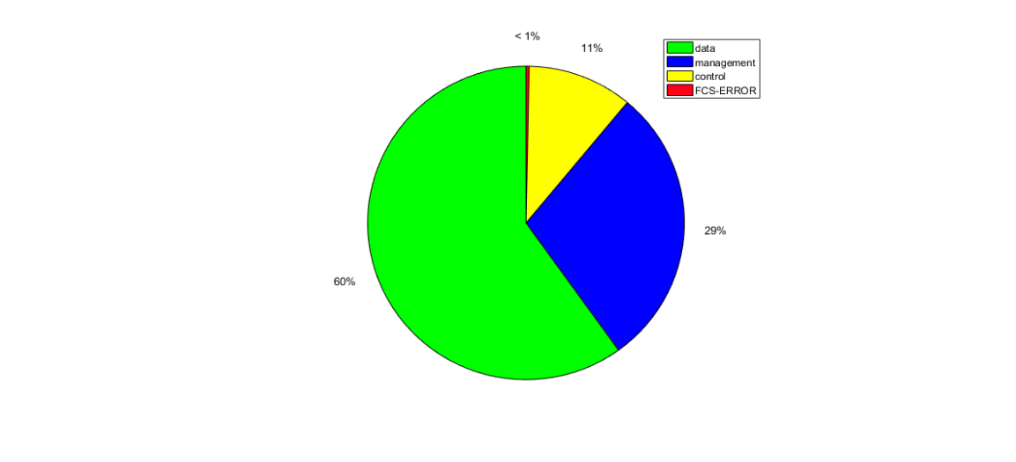

**Fig.7 Statistical Graph of frames (eduroam-update rate 1s)**

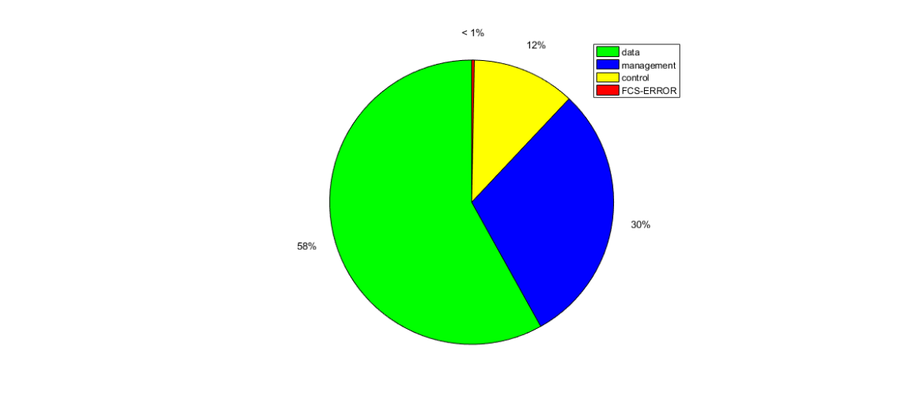

**Fig.8 Statistical Graph of frames (eduroam-update rate 5s)**

图片包含 矢量图形

已生成高可信度的说明

**Fig.9 Statistical Graph of frames (eduroam-update rate 30s)**

Now it’s time to evaluate the LAN performance and utilization. (As we said before, this network analyser might not be able to detect 4G data, so we can’t draw conclusion about Wi-Fi spot (vivo X7) from **Fig.4~6**. Thus, we only analyse the department’s Wi-Fi.) In my opinion, we could evaluate the LAN performance from the percentage of the size of FCS-ERROR frames. Because if two routers have same transmission protocols, and one router’s signals have larger transmission power, the receiver would receive less error frames, so we could say this router’s performance is better than the other one. We could tell from **Fig.7~9**, the percentage of FCS-ERROR is less than 1%, so the performance of one of LAN of our apartment is acceptable.

In the other hand, we could see transmitted utilization from **Fig.1~3**. When update time is 1 second, the values of transmitted utilization indicate instantaneous utilisation, whereas when update time is 5 seconds or 30 seconds, the values indicate average utilisation. These values are all lower than 10%, which means the ability to transmitting data of router was wasted. The utilisation of LAN (eduroam) is low at that time, so it indicates the router could connect more devices into this LAN.

**Reference**

Tanenbaum A., Wetherall D., 2011. Computer Networks. Pearson Education Asia Ltd.

Gallager R., 2008. Principles of digital communication. Cambridge University Press